**Assignment 11**

**You must create your own functions (user-defined).**

1. Display code description that has crime code from 302 to 305, display both columns.

CREATE FUNCTION displayCrimeCode()

RETURNS TABLE

AS

RETURN

(SELECT crime_code, code_description FROM crime_codes

WHERE crime_code >=302 AND crime_code <=305);

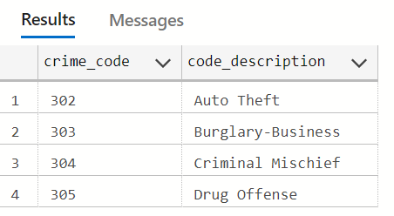

1. Display the lowest fine amount charged to a crime. Give the column an alias name “Lowest Fine Amount”

CREATE FUNCTION lowestFineAmount()

RETURNS TABLE

AS

RETURN

SELECT MIN(fine_amount) AS "Lowest Fine Amount" FROM crime_charges

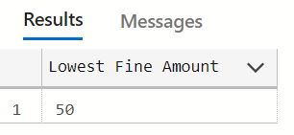

1. Write a query to return the current date along with time in MS SQL Server.

CREATE FUNCTION dateAndTime()

RETURNS TABLE

AS

RETURN

SELECT GETDATE() AS "Current Date and Time"

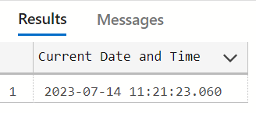

1. Add 10 days to the pay due date of the crime_charges table then display the result, name the column New_Due_date.

CREATE FUNCTION newDueDate()

RETURNS TABLE

AS

RETURN

SELECT DATEADD(day, 10, pay_due_date) AS New_Due_date FROM crime_charges

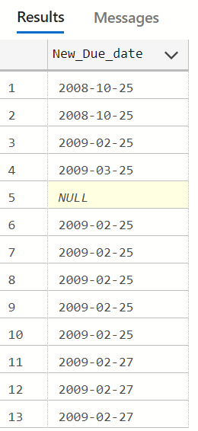

1. Display crime id and calculate how many days between filing and hearing dates, name this column “Days to Hearing”

CREATE FUNCTION daysToHearing()

RETURNS TABLE

AS

RETURN

SELECT crime_id, DATEDIFF(day, filing_date, hearing_date) AS "Days to Hearing" FROM appeals

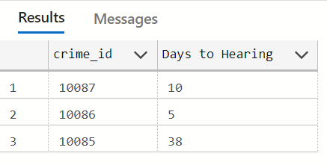

1. Display officer id along with their last names and the last five characters of their badges.

CREATE FUNCTION displayOfficers()

RETURNS TABLE

AS

RETURN

SELECT officer_id, [last], RIGHT(badge, 5) AS badge FROM officers

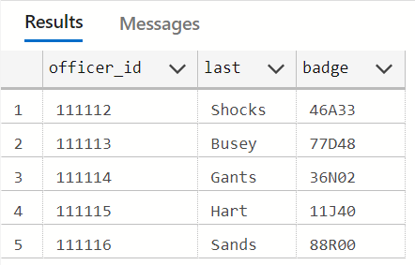

1. Write a query to display the probation officers’ id and their first and last names separated by comma in upper case letters, name the column O

CREATE FUNCTION displayPorbationOfficers()

RETURNS TABLE

AS

RETURN

SELECT prob_id, UPPER([first] + ', '+ [last]) AS O FROM prob_officers

